ТЕМА:

The Political Systems of the UK, the USA, the Russian Federation
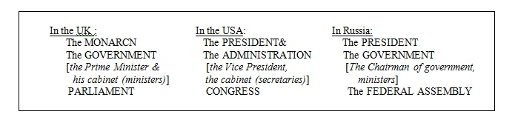
Обратите внимание на ударение в словах ниже:
- politics [‘pɔlətɪks] — политика (политическая жизнь)
- policy [‘pɔləsɪ] — политика (линия поведения)
- political [pə’lɪtɪk(ə)l] — политический (государственный)
- politician [ˌpɔlɪ’tɪʃ(ə)n] — политик (государственный деятель)
- parliament [‘pɑːləmənt] — парламент
- parliamentary [ˌpɑːlə’ment(ə)rɪ] — парламентарный
* * *

Перепишите и запомните английские слова по теме «The Political System of Different Countries»
- monarch [‘mɔnək] — монарх
- monarchy — монархия
- constitution — конституция
- constitutional monarchy — конституционная монархия
- democracy — демократия
- parliamentary republic — парламентская республика
- parliamentary democracy — парламентарная демократия
- ceremonial function — церемониальная функция
- sign the bills — подписывать законопроекты
- majority seats — большинство мест
- elected — избираемый
- a bill = a proposed law — законопроект
- lawmakers — законодатели
- legislative branch of power [‘leʤɪslətɪv]– законодательная власть
- executive branch of power [ɪg’zekjutɪv] – исполнительная власть
- to vote/ voting — голосовать / голосование
- to elect/ election — избирать / выборы
- carry out some policy — проводить политику
- run the country — управлять страной
* * *
Translate into English:
- An absolute monarch is a monarch who has unlimited power.
- A constitutional monarch is a monarch whose power is limited by a constitution.
- Monarchy is a system of government by a monarch.
Ознакомьтесь с сравнительной таблицей.

The Political System of the UK, the USA, Russia

(сравнительная таблица)
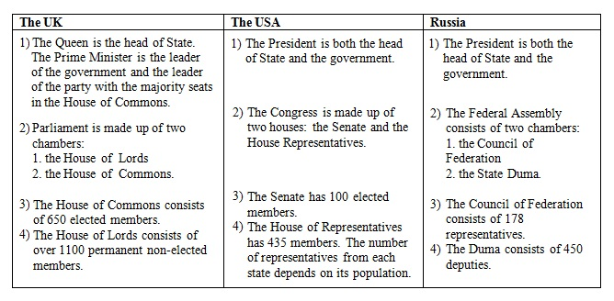

The Political System of the Russian Federation
The official name of Russia is the Republic of Russian Federation.
The Russian Federation is a federal (presidential, parliamentary) republic.
Mind the articles:
- The Federal Assembly – Федеральная Собрание (the Russian Parliament)
- The Council of Federation – Совет Федерации
- The State Duma – Государственная Дума
- The Council of Ministers = The Cabinet of Ministers – Совет министров (правительство)
- The Chairman of government= The Prime Minister – Председатель правительства
- The Supreme Court – Верховный суд
- The Constitutional Court – Конституционный суд
The Constitutional Court can declare actions of the president or government unconstitutional.
* * *

The Political System of Russia (основная информация)
- The president is the head of the state. He has much power: can dissolve the Duma, can veto laws.
- The National Government of Russia consists of the President, the Council of Ministers and the Federal Assembly.
- The legislative power in Russia belongs to the Federal Assembly. It consists of two houses or chambers: the Upper House (the Council of Federation) and the lower House (the State Duma).
- The Duma consists of 450 deputies.
- The executive power belongs to the government, e.g. to the Cabinet of Ministers, headed by the Prime-Minister.
- The head of government is the Prime Minister.
- The President is the Head of the executive branch. He is elected for a four-year term.
* * *
Write the answers to the following questions:
- Who is the head of the state in Russia?
- What bodies of power does the government consist of?
- Who is the head of the government in Russia?
- For how long is the President elected?
- What political system does Russia belong to?
* * *
Test on the Political System of Russia
- The official name of Russia is …..
  - Russia
  - the Russian Federation
  - the Republic of the Russian Federation
- The national Government of Russia consists of ….
  - the President and the Prime Minister
  - the President and the Council of Ministers
  - the President, the council of Ministers and the Federal Assembly
- There are ……Houses in the Federal Assembly.
  - two
  - three
  - four
- The lower House of the Federal Assembly is….
  - the State Duma
  - the Council of Ministers
  - the Federal Council
- The Head of the Republic of Russian Federation is….
  - the President
  - the Prime Minister
  - the Speaker of the State Duma
- The Duma consists of …. deputies.
  - 540
  - 450
  - 400
- The Chairman in Russia is…..
  - elected
  - invited
  - appointed
- In Russia ……can declare laws unconstitutional.
  - the President
  - the Supreme Court
  - Constitutional Court
- ……..elect the members of Federal Assembly.
  - the government
  - the people
  - the president

The Political System of the United Kingdom
ПЕРЕВЕДИТЕ и ЗАПОМНИТЕ:
- The UK is a constitutional monarchy and a parliamentary democracy.
- The monarch is the head of the state (Queen Elizabeth the Second)
She doesn’t rule the country, has ceremonial function; signs bills.
- The prime-minister is the head of the government.
He is the leader of the party with the majority seats in the House of Commons.
- Parliament consists of two chambers or houses:
the House of Lords
the House of Commons
The House of Lords consists of 651 MPs (elected). It makes laws.
The House of Commons consists of 1203 non-elected peers. It can delay bills and ask for rewriting certain parts.
- The head of the both Houses of Parliament is the Queen. She is also the head of the executive branch.
* * *
Прочитайте текст и ответьте письменно на вопросы:

Information to know about the Political System of the UK
- The legislative power belongs to Parliament. It makes laws.
- The House of Commons is more powerful: it decides national policy.
- The House of Lords has little political importance.
- The executive power belongs to the Government. It executes laws (puts them into effect.)
- Real power in the UK belongs to Parliament and the Government.
- The term “constitutional monarchy” means that GB is governed by Parliament, and the monarch is Head of State.
- The Queen has very little power. She has to put her signature on new laws even if she doesn’t like them.
- Her most important function is ceremonial. The Queen is a symbol of Britain’s long history and tradition. On great occasions she is driven through the streets in a golden carriage, guarded by soldiers.
- She represents Britain when she meets other heads of state. Every autumn she opens the Parliament. Every year she speaks on TV on Christmas day. She opens new hospitals, theatres and museums. After disasters she send messages to the families of the victims.
- The Queen of GB is also the Head of Commonwealth and also the Queen of Canada, Australia, New Zealand, etc. The Commonwealth is an association of former members of British Empire (British colonies) and Britain, which was formed in 1949.
Questions:
- What functions has Parliament ?
- What function has the Government?
- What does the Queen do?
- What does the term constitutional monarchy means?
- Why does the House of Lords have little political importance?
- What do the letters MP stand for?
- Is the Queen of the UK also the queen of some other countries?
- Do you think the idea of monarchy is out-of date?

Дополнительная информация для расширения кругозора:
The British constitution is often called the unwritten constitution because, unlike the constitutions of most other countries it is not a single documents, but a set of laws.
The first British constitution was Magna Carta which the King John was forced to accept in 1215. Its fundamental principles formed the base of the present one.
* * *
Some information about Royal family.
1. The family name of the present royal family is Windsor.*
2. Queen Elizabeth II became Queen in 1952.
3. Her husband’s name is Prince Philip.
4. She has 4 children (Prince Charles, Princess Anne, Prince Andrew, Prince Edward)
5. Her favourite animals are dogs.
6. The British monarchs are crowned in Westminster Abbey.
7. There are 600 rooms in Buckingham Palace.
8. Queen Victoria reigned for the longest period.
*This may sound very British, but the royal family ancestors were German. The present Queen’s great-great-grand mother, Queen Victoria (1819-1910) was born in Britain, but her mother and her husband were both German.

