06.04 deadline –10/04 на почту Neatgirl47@yandex.ru
Тема: Достопримечательности Родного края. Работа с обучающим текстом.
Чтение и перевод :

Home town plays a great role in our life. My hometown is Rostov on-Don. Rostov is located in the south of Russia. It is a big cosmopolitan city.
My city is famous for many things. Fist , There are a few well-established universities which are great learning seats. Second , Rostov is proud of its theatres, galleries and museums. Also, Last summer Rostov hosted The world football championship. Football fans from all over the world came to Rostov to cheer their teams. As for my favourite place in Rostov . it is the park called Revolution Park. I like to hang out there with my family and ride on the observation wheel. When I leave school I am not going to stay In my hometown because I am planning to apply to Moscow state l university for a place at Linguistic faculty. I want to make the grade as a top-notch interpreter. In conclusion, Rostov is my pride and joy and I love my city to pieces.
Public holidays play an important part in our life. There are a lot of holidays in Russia .We celebrate New Year’s Day , Christmas Day, Defender of the Fatherland Day, International Women’s Day, Ester, Victory Day, Spring and Labor Day , Russia Day, Unity Day. My favourite public holiday is New Year’s Day because My parents who have a tight schedule can spend quality time with me this day. Besides , I like making New Year presents and giving them to my family. Usually People in my city , put up a New Year Tree, decorate their flats with tinsels, lights. We cook delicious meals, have family get-togethers to see in the New Year. At parties , We dance, play games and have fun.
In conclusion, people should celebrate holidays to remember their country’s traditions and history.

Перевод-

Russia (Russian: Россия), officially called the Russian Federation (Russian: Российская Федерация)^{[11]} is a country that is in Eastern Europe and in North Asia. It is the largest country in the world by land area. About 146.7 million people live in Russia according to the 2019 census. The capital city of Russia is Moscow, and the official language is Russian.
Russia shares land borders with Norway, Finland, Estonia, Latvia, Lithuania and Poland (both via Kaliningrad Oblast), Belarus, Ukraine, Georgia, Azerbaijan, Kazakhstan, China, Mongolia, and North Korea. It also has borders over water with Japan by the Sea of Okhotsk, and the United States by the Bering Strait.
Russia is a very large and diverse country, but today its government is a federal semi-presidential republic. It has elements of democracy. The President is chosen by direct election, but challenging candidates do not have access to the mass media, and so have almost no chance of winning.^{[12]} Its current President is Vladimir Putin. The President rules the country, and the Russian Parliament plays a secondary role.
Russia is a federal semi-presidential republic. It has a president and a parliament.^{[21]} Russia consists of 85 federal subjects (territorial units). Duma (Russian parliament)
09.04 Внешность , черты , характер человека.
Текст : Обо мне и моем окружении
чтение , перевод
Oh. Where can I start? I'm Sophia Swede. I was born on 31st May 1981 in Debrecen. My nickname is Tiny because I'm only 155 cm tall. This nickname is from my brother, Tom. I'm a bit plump, so I'm on a diet. I want to lose some weight. I've got medium-length brownish-red hair and brown eyes. My eyes are big and I've got long eyelashes. I usually wear some make-up. I generally wear a dress or a skirt with a blouse or a top. I put on something casual when I'm at home, especially when I play with my son. I like jewellery and high-heeled shoes. As I said before I'm a bit perfectionist. I always try to do my best. I love my family. They are the first. I think, I'm reliable, warm-hearted, honest and careful.
My family and my friends can count on me. One of my bad habits is that I can easily get worried, and the other is I'm really talkative.
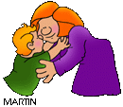
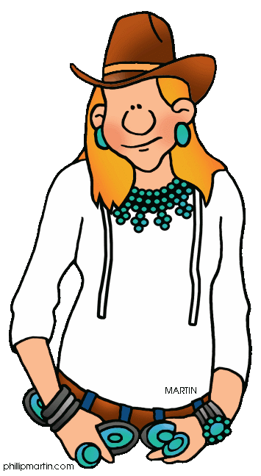
So I'm Violet Greene a 22-year-old student. I was born on 3rd October 1989 in Paks. My friends call me Letty. I'm quite tall, 178 cm tall. I've got medium-length blonde wavy hair. I've got green eyes. I think my nose is a bit big, but I like my oval face. There is one more part of my body that I don't really like.
My ears are protruding. I'm slim, but I should do some work-out to be fitter. I usually wear a top or a sweatshirt with a pair of jeans. I prefer casual clothes. When I have an exam I generally wear a dress or a suit. I like all kinds of jewellery.
What can I say about my personality? I'm determined and busy. I'm wary; I like to know from which options I can choose. I always try to find out the best way to reach my goal, so I'm moderate, too. I'm loyal, nice and helpful, as well.

